St. John’s Church of Auburn, PA
Pastors of the first 100 Years

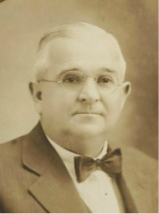 | 1910  1938 | Robert S. Edris – When a joint congregational choir was
 |  | being considered at St. John’s Church of Auburn, Reverend
 | R | Edris stated “they would have nothing to do with a joint
 |  | choir” during his term as pastor at the church.
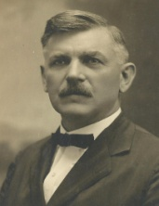 | 1912  1925 | Howard Hoffman Krauss – Reverend Krauss served both as
 |  | pastor for St. John’s Church of Auburn, Pennsylvania as well
 | L | as a principal for the Auburn School during his residence in
 |  | Auburn. He died on June 1st, 1953 at 77 years of age.
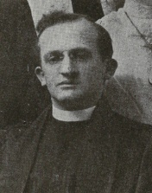 | 1927  1932 | W. J. Huntsinger – An archival ledger described this pastor
 |  | as a “sick man” who had physical ailments which impacted
 | L | his ability to perform his pastoral duties and stated that he
 |  | had a “lack of tact” which alienated him from members.
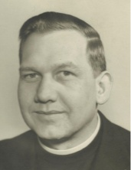 | 1933  1942 | Gilbert John Martin – Reverend Martin was remembered
 |  | quite favorably as having been “highly productive” and
 | L | for his beneficial efforts in making numerous improvements
 |  | and implementing new programs and ideas in the church.
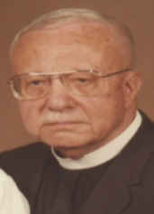 | 1938  1941 | W. Miller Price – Reverend W. Miller Price was born on
 |  | Halloween of 1903. His wife was Verna F. Miller Price. He
 | R | served St. John’s Church in Auburn, Pennsylvania for about
 |  | three years. He died in March of 1987 at 83 years of age.
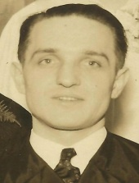 | 1942  1948 | Lee D. Loos – Reverend Lee D. Loos was born in September
 |  | of either 1911 or 1912 (records conflict). He was married
 | R | to Mary T. Loos. He died on January 11th, 1988 and was
 |  | interred in Belleman’s Church Cemetery of Mohrsville, PA.
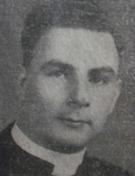 | 1942  1946 | Walter J. Drumm – Reverend Drumm was a graduate of
 |  | Susquehanna University of Selinsgrove, PA. He lived on
 | L | Washington Street during his stay in Auburn and donated
 |  | the Missal Stand to St. John’s Church of Auburn in 1943.
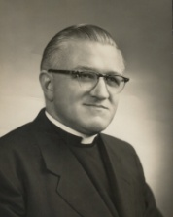 | 1946  1953 | Charles T. Herman – Reverend and Mrs. Herman resided in
 |  | the newly remodeled parsonage on Washington Street in
 | L | Auburn. Reverend Herman was a member of the Auburn
 |  | Lions Club and a member of the Boy Scout Committee.

