St. John’s Church of Auburn, PA
Pastors of the first 100 Years

 | 1865  1873 | Richard Solomon Appel – Reverend Appel was born in
 |  | Weisenberg, Pennsylvania in 1842. He decided at an early
 | R | age to enter into the ministry. He served St. John’s Church
 |  | for approx. eight years. He died in 1927 at 84 years of age.
 | 1869  1870 | Gottleib F. Woerner – Reverend Woerner also performed
 |  | some of his pastoral duties on horseback. He was later
 | L | investigated by the Synod in 1876 regarding “a matter
 |  | of church discipline relative to (Reverend Woerner)”.
 | 1870  1871 | Daniel Kepner – Reverend Kepner was a third consecutive
 |  | Lutheran pastor to perform a portion of his duties while
 | L | mounted on horseback. Records indicate that Reverend
 |  | Daniel Kepner may have been married twice.
 | 1871  1888 | Isaac Newton S. Erb – Reverend Erb was instrumental in
 |  | the erection of a “much-need school building” located in
 | L | Orwigsburg, Pennsylvania. His daughter married his
 |  | successor at St. John’s Church, Reverend Harvey A. Weller.
 | 1873  1902 | Henry Leise – Reverend Leise was born in 1840 to Martin &
 |  | Mary Leise. He served almost three decades at St. John’s
 | R | Church of Auburn, Pennsylvania. Reverend Henry Leise
 |  | died in 1902 and was interred in Wall Rose, Pennsylvania.
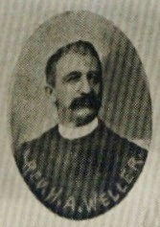 | 1889  1912 | Harvey A. Weller – Reverend Weller is best remembered
 |  | for the picture titled “The Resurrection” displayed on the
 | L | interior eastern wall of St. John’s Church of Auburn, Penna.
 |  | He and his daughter painted and donated the picture.
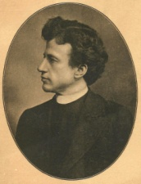 | 1903  1905 | William D. Stoyer – Reverend William D. Stoyer was born in
 |  | 1869. He served St. John’s Church of Auburn, Pennsylvania
 | R | for approximately two years. He died in 1935 and was
 |  | interred in the Greenwood Cemetery, Tower City, Penna.
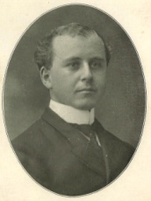 | 1906  1910 | J. Arthur Schaeffer – Reverend Schaeffer and his wife Stella
 |  | nee Hoover Schaeffer raised a son Royce E. Schaeffer who
 | R | later entered into the ministry himself as a U.C.C. pastor,
 |  | following the same path & calling of his revered father.

