 |  |  |  |  |  | 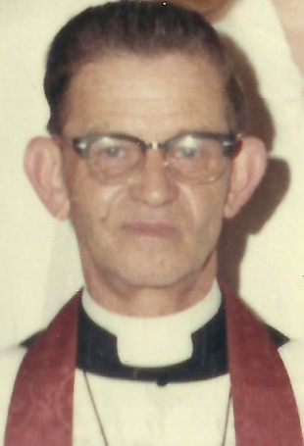
Leisse,  Rev. Henry |  |  | Leonberger,  Rev. F. |  |  | Linn,  Rev. Luther J.
1873 - 1902 | R |  | 1864 - 1869 | L |  | 1968 - 1980 | L
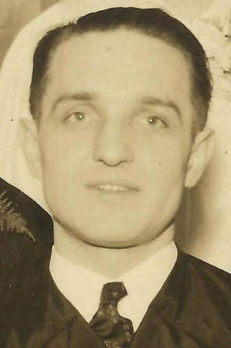 |  |  | 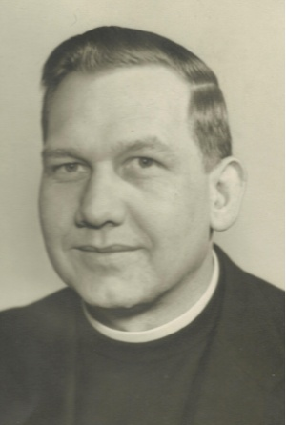
Loos,  Rev. Lee D. |  |  | Martin,  Rev. Gilbert J. |  |  | Meyer,  Rev. Philip
1942 – 1948 | R |  | 1933 – 1942 | L |  | 1845 - 1857 | R
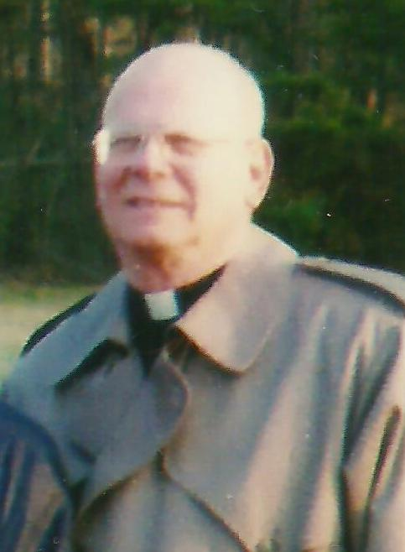 |  |  | 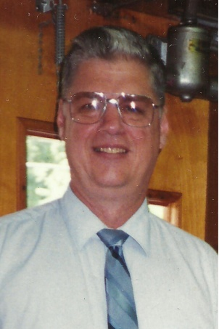 |  |  | 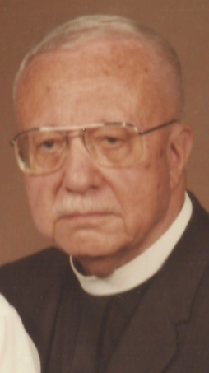
Miller,  Rev. George |  |  | Pierson,  Rev. Larry |  |  | Price,  Rev. W. Miller
2003 - 2006 | J |  | 1992 - 1993 | R |  | 1938 – 1941 | R

