 |  |  | 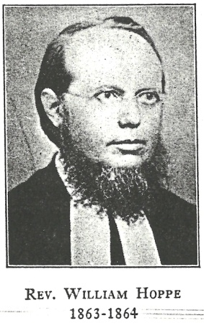 |  |  | 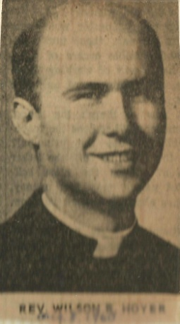
Hollinger,  Rev. Harold |  |  | Hoppe,  Rev. Carl F. W. |  |  | Hoyer,  Rev. Wilson R.
1997-1998 | R |  | 1861 – 1864 | L |  | 1960 – 1963 | L
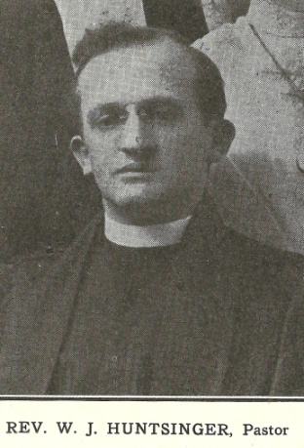 |  |  |  |  |  | 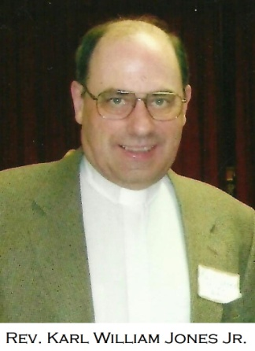
Huntsinger,  Rev. W. J. |  |  | Jaeger,  Rev. Nathan |  |  | Jones,  Rev. Karl W. Jr.
1927 – 1932 | L |  | 1845 - 1852 | L |  | 2006 – 2008 | J
 |  |  | 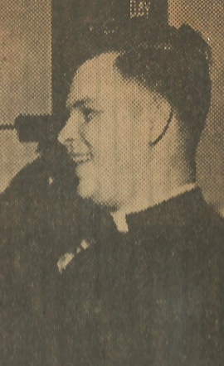 |  |  | 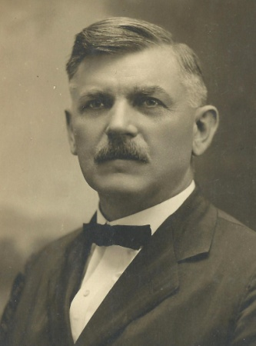
Kepner,  Rev. Daniel |  |  | Kistler,  Rev. Robert C. |  |  | Krauss,  Rev. Howard H.
1870 - 1871 | L |  | 1963 – 1967 or 1968 | L |  | 1912 - 1925 | L

