PAST PASTORS OF ST. JOHN’S CHURCH (up to 2015)

If a church is viewed as an entity, then the congregational members would be its “body”, the church council (or board) would be its “mind” and the pastor would be its “heart”. When all three components are present and working in synchronization, the church prospers and grows. When one or more of these components are missing or failing, the “health” of the church suffers as well.
The spiritual “heart” of the church is its Pastor. The pastor is responsible for the spiritual and emotional well-being of the church. A good pastor possesses the capability to pump the “life-blood” into the church. They are instrumental in attracting new parishioners as well as retaining and providing service to existing members.
The word “pastor” originates from the fourteenth century Latin word of the same spelling which literally meant a “herdsman”. Like the “pastors” from centuries ago, the pastor of today’s church tends to the flock and attempts to keep any member from going astray. The following is a chronological list of the pastors who have served our congregation over the decades:

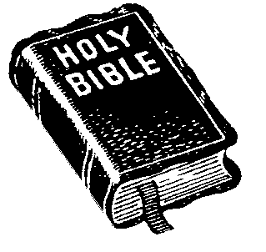
Nathan Jaeger (or Yeager) (Served 1845 – 01/01/1852) – Nathan Jaeger was born in Bucks County on March 20th (or 2nd or 21st), 1820. He resided in the Berrysburg, Pennsylvania area at one point. He was a student of the Pennsylvania College of Gettysburg, PA from 1839 until 1841. He then began studying theology under the Reverend J. P. Hecht of Easton, PA. He married Mary Matilda Miller and fathered at least eight children. He was a prior theological student and subsequent son-in-law of Reverend Henry S. Miller. He “secured license of the Ministerium” in Pottstown, PA on June 5th, 1844. The Reverend Jaeger was bi-lingual (at least), speaking both German and English. Reverend Jaeger was the first pastor of Scotchman’s Locks (later to be named Auburn). Starting in 1845, he served in the Meeting House constructed at the corner of Schoenersdale Road (now Mill Street) and Bear Creek Street beside the original cemetery. He was ordained in Orwigsburg, PA on June 10th, 1846. He continued his service at Auburn until January 1st, 1852. He then served as Pastor to St. John’s Lutheran Church in Boyertown, PA from 1852-1857.
According to a newspaper article published April 2nd, 2000 pertaining to the history of the New Hanover Evangelical Lutheran Church written by Cynthia J. McGroarty of the “Inquirer Suburban Staff” - “In 1853, the Rev. Nathan Jaeger, characterized by Kline as ‘a superior catechist’ but ‘a mercenary man,’ arrived. Jaeger scandalized the congregation with his ‘secular engagements’ and worldly pursuits, according to Kline's history, and he resigned under a cloud of controversy in 1857”. His “secular engagements” included “running quarries” and “burning lime” which resulted in him being nicknamed “the Lime-burner” by some of his congregation. Unfortunately, he was not a successful businessman and subsequently a committee was appointed to investigate his transactions. While he was found not guilty of intentional dishonesty, the committee “expressed strong disapproval of his course in involving himself in such manner that he could not meet his obligations”. A quote from the time of his demise reads “While driving in the neighborhood of Easton, his horse was frightened (by a railroad train, throwing him from the saddle) and ran away. Reverend Yeager died (almost instantly) from the effect of his injuries.” His death occurred on January 2nd, 1864 at 43 years of age. He was buried in the Riegelsville Union Cemetery, Riegelsville, PA. His tombstone inscription reads “Pastor of St. Peter’s Lutheran Church” and “Mar. – Dec. 1863”.

Philip Meyer (Served 1845-1857) – The Reverend Philip Meyer served the Auburn parish from 1845 until 1857. Reverend Meyer is deceased. No further information pertaining to Reverend Philip Meyer is available at this time.

George W. Scheide (Served 01/25/1852 – 12/25/1852) – A Reverend G. W. Scheide, possibly the same Rev. George W. Scheide who served at St. John’s Church of Auburn, once served as a Professor at Andalusia College located in Bucks County, PA, teaching Latin, Greek and German. During his pastorship in Auburn, PA, the Reverend Scheide had resided in the town of Orwigsburg, PA. Although Reverend Scheide had only begun his pastorship on Sunday, January 25th, 1852, he was asked by the members of the board to resign on Saturday, December 25th, 1852 due to his “fanatical habits”. An archival ledger belonging to St. John’s Church has an entry which reads that Reverend Scheide “became a fanatic” and “was dismissed from Lutheran Ministry”. Reverend Scheide is deceased.

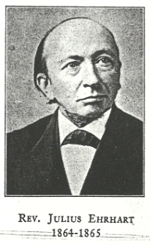
Julius Ehrhart (or Earhart or Erhart) (Served 04/03/1853 - 1860) – Julius Earhart was born in 1824. He spoke the German language and is presumed to have also been fluent in English. The Reverend Julius Ehrhart was once described as possessing "great oratorical ability and personal magnetism". He possibly served in Michigan prior to coming to Pennsylvania. He was elected to serve as pastor in the “Meeting House” of Auburn, PA on Sunday, April 3rd, 1853. He was present for the transition of the congregation to the “church on the hill” (St. John’s Church’s current location) in the late 1850s. The land for the church was purchased on Friday, July 24th, 1857 for the amount of $1.00. Reverend Earhart left the Auburn parish in 1860. He possibly migrated to the state of New York during his later years and eventually died in 1899.

Henry Wagner (Served 1858 - 1865) – Henry Wagner was born on April 1st, 1802. His spouse was Sophia P. (Schneck) Wagner. His daughter was Caroline Sarah Wagner (b. 1838 – d. 1861). The Reverend Wagner began service at St. John’s Church in Auburn in 1858. He later left the Auburn Church in 1865. Reverend Wagner died on Sunday, May 23, 1869 at the age of 67 and was buried in the Mount Lebanon Cemetery, Lebanon, PA; Plot -Section E.

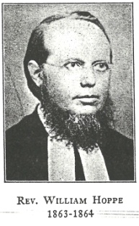
Karl (or Carl or Charles) Friedrich (or Frederick) William Hoppe (Served 11/1861 – 06/1864) – Carl Frederick William Hoppe was born on March 4th (or March 14th), 1824 (conflicting reports exist) in Hanover, Germany. He was educated in the Heidelberg University of Germany prior to immigrating to America when he was twenty-eight years old. The Reverend Hoppe was ordained in either 1854 or 1855 by the Western Pennsylvania Synod. He served the St. Stephen’s Church in Baltimore, Maryland prior to coming to the Auburn parish in November of 1861. Reverend Hoppe resided in the town of Orwigsburg, PA during his stay in Schuylkill County. He left the Auburn parish in June of 1864. Reverend Hoppe died in Rochester, New York on April 4th, 1881. He was 57 years old.

John Henry Eberman (Served 09/25/1864 – 11/06/1864) – John Henry Eberman was born in 1832 in Lititz, PA. His father was the Reverend William Eberman. His spouse was Anna (Senseman) Eberman. He initially served at a Moravian church, but “In consequence of domestic troubles he exchanged the service in the Moravian Church for that in the Lutheran”. The Reverend Eberman served the Auburn parish from Sunday, September 25th, 1864 until Sunday, November 6th, 1864. From the “Guide to Old Moravian Cemetery of Bethlehem, PA 1742 – 1910” by Augustus Schultze, D.D.L.H.D. in Lancaster, PA (1912) the following information is included “John Henry Eberman, 1832-68, born at Lititz, Pa.; son of Rev. William Eberman. He studied theology, taught at Nazareth Hall, and was minister at West Salem. He married Anna Senseman. In consequence of domestic troubles he exchanged the service in the Moravian Church for that in the Lutheran, and died at Schuylkill Haven, Pa.” Reverend John Henry Eberman died on September 23rd, 1868 in Schuylkill Haven, PA and was buried in the Moravian Cemetery, Bethlehem, PA in Plot: Section H, Row III – Boys & Men, 22.

F. (or J.) Leonberger (Served 12/25/1864 – 07/04/1869) – F. Leonberger was born Sunday, January 6th, 1822. He was ordained in 1849. The Reverend Leonberger was elected to the Auburn parish on Sunday, December 25th, 1864 and was subsequently installed in Auburn in 1865. Records indicate that he did much of his pastoral work on horseback. He served at Auburn until Sunday, July 4th, 1869. Reverend Leonberger died on September 7th, 1886 at 64 years of age. He was buried at Zion United Church of Christ Cemetery, Baltimore County, Maryland.

Richard Solomon Appel (Served 1865 – 1873) – Richard Solomon Appel was born in Weisenberg, Pennsylvania on February 12th (or 14th), 1842. He decided at an early age to enter into the ministry. He attended Allentown Seminary; Franklin & Marshall College; Mercersburg Seminary; Lehigh University and Ursinus College. The Reverend Appel began ministry at Becker’s St. Peter’s Church of Molltown, PA where he served for sixty-two years. He also served the Auburn parish from 1865 – 1873. Reverend Appel married Alice M. Blumer on September 21, 1869. He had one son whose name was Robert. At 84 years of age, Reverend Appel died on January 4th, 1927. He was buried in St. John’s Cemetery; Hamburg; PA. Plot: 3-1504-4-2-38.

Gottleib F. (Woener or) Woerner (Served 1869 – 1870) – The Reverend G. F. Woerner was married to Fredericka Woerner (b. Feb. 8, 1829 – d. Jul. 29, 1892). He served the Auburn parish briefly from 1869 to 1870. He, too, conducted most of his pastoral work on horseback. An article in the Reading (PA) Times Newspaper dated June 16, 1876 mentioned that a Reverend G. F. Woerner, Pastor of the Emmanuel Church of Williamsport, PA was the topic of discussion by the Church Synod for an hour and a quarter during a recent meeting. The discussion, a great deal of which was conversed in German, revolved around “a matter of church discipline relative to (Rev. Woerner)”. A committee was appointed to proceed to Williamsport to investigate the matter. The Reverend preceded his wife in death. He is buried in the West Laurel Hill Cemetery, Bala Cynwyd, PA.

Daniel (A. or H. or K.) Kepner (Served 1870 – 1871) – Daniel Kepner was born in 1825. Conflicting records indicate he had two wives. His “first” spouse was Leah (Crist) Kepner (b. 1826 – d. 1894). The “second” spouse listed is Martha E. (Oliver) Sowers Kepner (b. 1843 – d. 1904). While it is not impossible, the second spouse listed shows an eighteen year age difference and therefore might be the more likely erroneous entry. The Reverend Daniel Kepner was yet a third pastor for Auburn who was recorded as having “Served on horse-back”. He served the Auburn parish during the years of 1870 and 1871. Rev. Kepner died on April 1st, 1901 at the age of 76 years and is buried at the Millerstown Memorial Cemetery of Perry County, PA.

Isaac Newton S. Erb (Served 08/13/1871 – 04/29/1888) – Isaac Newton S. Erb was born on June 21st, 1813. His parents were David and Julia Erb. He attended Muhlenberg College and graduated in 1870. He was an active member of the Euterpean Literary Society at the college. He later presided over the Muhlenberg College Alumni Association. He was married and was known to have at least one daughter. The Reverend Erb is listed as having served the Auburn parish from Sunday, August 13th, 1871 to Sunday, April 29th, 1888. He attended Mt. Airy seminary and graduated from there in 1873. He was ordained in June 1873 at a meeting of the Ministerium of Pennsylvania held in Pottsville, PA. Reverend Erb was listed as “attended Orwigsburg (PA)” in 1875 for an appointment of $125. He was instrumental in the erection of a “much-needed school building” in Orwigsburg. His daughter was married to his successor (The Reverend H.A. Weller). Reverend Erb died on Sunday, April 29th, 1888 while in active service at 74 years of age.

Henry Leise (Served 1873 – 1902) – Henry Leise was born in 1840. His parents were Martin Leise (1813-1885) and Mary Leise (1816-1887). The Reverend Leise served the Auburn parish for almost three decades from 1873 through 1902. Reverend Leise died in 1902 and was buried in St. Matthew’s Evangelical Lutheran Church Cemetery; Wall Rose; PA.

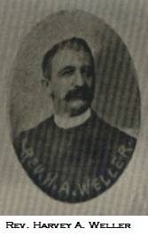
Harvey A. Weller, D.D. (Served 03/1889 – 1912) – The Reverend Weller was elected to service in Auburn in March of 1889. He accepted the call after his ordination in June of 1889. He is perhaps most remembered for having painted (with his daughter) the picture which is featured at the front of the church titled “The Resurrection”. Reverend Weller then subsequently donated the picture to the church upon its completion in 1903. Reverend Weller also created the Women’s Missionary Society of Auburn, PA in 1905. He wrote a history entitled “A Documentary History of the Old Red (Zion) Church in West Brunswick Township, Schuylkill County, Pennsylvania” on behalf of the Historical Society of Schuylkill County in September of 1908. Reverend Weller asked the Synod to be relieved of the Auburn Parish in 1912 in order that he might serve only the Orwigsburg church. He became the President of the Ministries of Pennsylvania in 1916. Reverend Well is deceased.

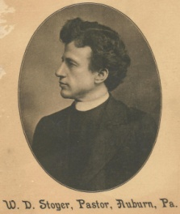
William D. Stoyer (Served 1903 - 1905) – W. D. Stoyer was born in 1869. The Reverend Stoyer began his service with the Auburn parish in 1903 and served there until 1905. Reverend Stoyer died in 1935 and was buried in the Greenwood Cemetery, Tower City, Pennsylvania.

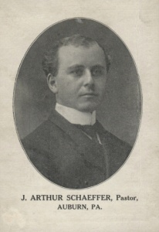
J. Arthur Schaeffer (Served 1906 – 1910) - The Reverend Schaeffer served the Auburn parish from 1906 until 1910. Reverend Schaeffer is deceased. No further information is available on this pastor at this time.

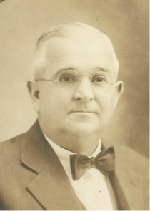
Robert S. Edris (Served 1910 – 1938) – The Reverend Edris served the Auburn church from 1910 through 1938. When the consideration for a joint congregational choir was posed during his term, he stated “they would have nothing to do with a joint choir”. This bias reflects an un-Christian-like attitude and highlights the underlying conflict between the congregations at this time. The bible tells us that we should be “singing to God with gratitude in your hearts” (Colossians 3:16). Reverend Edris is deceased. No further information is available about this pastor at this time.

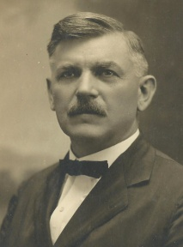
Howard Hoffman (Krause or) Krauss (Served 10/1912 – 10/31/1925) – Howard Hoffman Krauss was born on March 7th, 1876. His parents were Henry S. Krauss (1846-1929) and Amanda (Hoffman) Krauss (1852-1927). He wife was Susan Wiegner (Kriebel) Krauss (1882-1961). His children were Alberta Kriebel (Krauss) Slotter (1912-1960), Frederick Kriebel Krauss (1912-1995), Ida May (Krauss) Kepner (1914-2003), Mary Virginia (Krauss) Ganzhorn (1923-1998) and Winifred Kriebel (Krauss) Freed (1910-1999). One reference states that he “Became Pastor of Auburn Parish on 10/03/1912”, while another states that the Reverend Krauss began his service here on October 15th, 1912. Reverend Krauss also served as principal of the Auburn schools, as well as a member of the Auburn Board of Trade and the Auburn Borough Council, during his time here. He submitted his resignation to St. John’s Church of Auburn on September 25th, 1925 with the intent to become Pastor of the St. Paul’s Lutheran Church of Red Hill, PA. Reverend Krauss left Auburn’s parish on October 31st, 1925. He died June 1^{st,} 1953 at 77 years of age. He is buried at St. Paul’s Lutheran Cemetery; Red Hill; PA in Plot: New Section E, Row 8. Reverend Krauss’ tombstone inscription reads “Pastor of this congregation from 1925-1953”.

(1925 – 1927) – The Lutheran congregation’s parish is vacant during this period. Auburn asks for and is granted independence from its current parish affiliation.

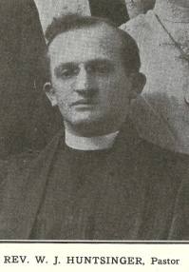
W. J. Huntsinger (Served 07/01/1927 – 09/01/1932) – In January of 1927, the church council conducted a vote for the Reverend Huntsinger to assume duties at their church. The tally was 21 to 6 in favor of him serving Auburn. He began his duties Friday, July 1st, 1927. An archival ledger of St. John’s Church contains a later entry of “Unfortunately Pastor Huntsinger was a sick man. He wasn’t able to take care of his pastoral duties and couldn’t do justice to those he did take care of.” Reverend Huntsinger was also noted as having “had physical ailments” and a “lack of tact” which alienated members. Reverend Huntsinger submitted his resignation from the Auburn parish on Sunday, June 12th, 1932 stipulating an effective date of September 14th, 1932. He left the parish on September 1st, 1932. Reverend Huntsinger is deceased.

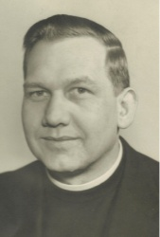
Gilbert John Martin (Served 01/01/1933 – 04/15/1942) – Gilbert John Martin was born on April 3rd, 1907 in East Bangor, PA. His father was John H. Martin. His wife was Sylvia C. (Stiles) Martin (b. 08/23/1907 - d. 08/31/1996). He had at least two sons. He graduated Bangor High School in 1925. He was a graduate of Muhlenberg College of Allentown in 1929. He then graduated the Philadelphia Lutheran (Mt. Airy) Seminary in 1932. On December 11th, 1932, the Auburn council elected the Reverend Martin “of East Bangor, PA” to serve their parish. He received call to the Auburn parish on December 25th, 1932. Reverend Gilbert J. Martin accepted the position and was ordained on December 26th, 1932. He began duties on January 1st, 1933. Reverend Martin was officially installed with the Auburn parish on January 7th, 1933. He was remembered quite favorably by members of the congregation according to archival statements which inform us that Reverend Martin was considered “highly productive” and that his efforts were “beneficial” in making numerous improvements and implementing new programs or ideas. Reverend Martin also greatly boosted attendance levels for the church. He eventually resigned from the Auburn parish on April 15th, 1942 in order to attend to St. John’s Church in Tamaqua, PA where he served until 1952. He received a Bachelors of Divinity Degree from the seminary in 1946 as well as having received his Masters Degree of Sacred Theology from the seminary in 1951. He did further graduate work at Princeton Theological Seminary. Reverend Gilbert John Martin, having been ill for two years, died at his home in Lancaster on December 15th, 1978 at 71 years of age. He is buried in East Bangor Cemetery; East Bangor, PA.

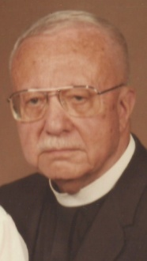
W. Miller Price (Served 1938 – 1941) – W. Miller Price was born on October 31st, 1903. His wife was Verna F. Miller Price. The Reverend W. Miller Price served the Auburn parish from 1938 until 1941. He died in March of 1987 at 83 years of age and is buried in Grand View Memorial Park, Annville, PA - Plot: Section A.

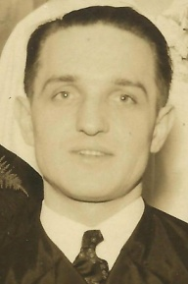
Lee D. Loos (Served 05/1942 – 01/1948) – Lee D. Loos was born on September 2nd, 1911 (or 1912). He was married to Mary T. Loos (b. 1908 – d. 1999). The Reverend Loos served the Auburn parish from May of 1942 until January of 1948. He died on January 11th, 1988 and was buried in Belleman’s Church Cemetery, Mohrsville, PA.

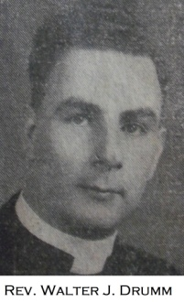
Walter J. Drumm (Served 06/01/1942 – 05/01/1946) – Walter J. Drumm was born in the Sunbury, PA area on April 22nd, 1916. His parents were Claude C. Drumm and Maude E. (Folk) Drumm of Danville, PA. Walter Drumm was a graduate of Sunbury High School, Sunbury, PA and a graduate of Susquehanna University, Selinsgrove, PA in 1939. He went on to graduate from the Philadelphia Lutheran Theological Seminary at Mt. Airy on May 13, 1942. The Reverend Drumm was elected to serve Auburn on May 10th, 1942 (three days prior to his graduation date from Mt. Airy). He was subsequently ordained on May 20th, 1942. Reverend Drumm began service to Auburn parish on June 1st, 1942 and was officially installed on June 14th, 1942. He married Roselear Katherine Glass of Philadelphia, PA on September 12th, 1942. They had a daughter Annette and a son John Walter Drumm. The Drumms lived on Washington Street while he served in Auburn. He and his wife anonymously donated the Missal stand for the church in 1943. Reverend Drumm submitted his resignation from Auburn on April 14th, 1946 to be effective May 1st, 1946. His intent was to become pastor of St. Paul’s Evangelical Lutheran Church of Numidia, PA. Reverend Drumm left the Auburn parish on May 1st, 1946. He died on Saturday, May 30th, 1969 at his home in Berwick from an apparent heart seizure. He is buried in St. Luke’s Lutheran Church Cemetery; Sunbury, PA.

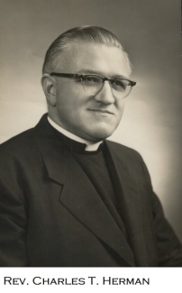
Charles T. Herman (Served 10/15/1946 – 11/01/1953) – Charles T. Herman was born in 1906. His wife was Verna (Swab) Herman. He had two sons, Paul and Richard C. Herman. He was a graduate of the Allentown Preparatory School; Muhlenberg College and the Lutheran Theological Seminary of Philadelphia, PA. He previously served as the pastor for the Urban Lutheran Parish of Urban, PA. He resided in Topton, PA prior to transferring to Auburn. The Reverend Herman was elected to the Auburn parish on August 18th, 1946 and was accepted into the parish on October 15th, 1946. Reverend and Mrs. Herman moved into newly remodeled parsonage on Washington Street and he began serving in his position on October 15th, 1946. He was officially installed into St. John’s church on October 27th, 1946. He was on the community Boy Scout Committee in Auburn and was a charter member of the Auburn Lions Club. Reverend Herman resigned on November 1st, 1953 to accept a position with Bowers Parish near Topton, PA. He died on Wednesday, January 2nd, 1985 at 79 years of age while residing at the Lutheran Home of Topton. He was buried at St. John’s Lutheran Church Cemetery, Berrysburg, PA.
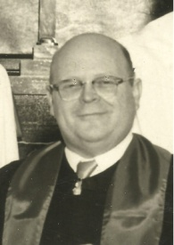
Raymond C. Zechman (Served 06/1948 – 1955) – The Reverend Raymond C. Zechman served St. John’s church of Auburn from June of 1948 until 1955. In the late 1950s, Rev. Zechman was conducting missionary work among the American Indians (Native Americans).

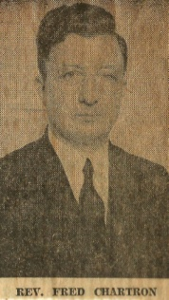
Fred “Fritz” R. Chartron (Served 05/1954 - 1955) – Fred “Fritz” R. Chartron was born in 1903 in Berlin, Germany. He was the son of Frederick Chartron and Hulda Chartron. He also had (at least) one sister, Elizabeth Chartron Arndt. He was married to Emma Wahl Chartron. They had (at least) one son named Frederick W. Chartron and one daughter named Elizabeth Chartron. Fred’s initial aim in life was to become a missionary. He prepared for the ministry at the University of Berlin, Germany. He graduated from the university in 1929 with a degree in medicine. Fred was ordained as a minister in the German State Evangelical Lutheran Church. Fred traveled to America where he sought employment in farming and later in industry. He decided to become a minister in this country and graduated from the Eden Theological Seminary of Webster Grove, Missouri in 1936. At that point, Fred had mastered the languages of English, German, Greek and Latin. Reverend Chartron began service to the Auburn parish in May of 1954. In 1955, he resigned from St. John’s Church to go to St. Peter’s German Lutheran Church in Allentown, PA. Reverend Chartron died in 1969. He is interred within the Woodlawn Memorial Park, Allentown, Lehigh County, PA.

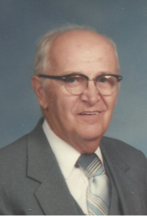
Warren O. Ziegler (Served 01/1956 – 11/1962) – Warren O. Ziegler was born in Mount Aetna, PA. His parents were Harvey and Gertrude M. (Krick) Ziegler. His wife was Irene E. (Marburger) Ziegler. She was born in 1920 and died on May 16th, 2004. His children included two sons, Merwin J. and Dwight L. Ziegler. Warren Ziegler was a graduate of both Franklin and Marshall College and the Lancaster Theological Seminary of Lancaster, PA. The Reverend Ziegler was ordained as a minister in the United Church of Christ circa 1944. He served as pastor at several parishes throughout Pennsylvania and Maryland to include St. John’s church of Auburn. He served the Auburn parish from January of 1956 through November of 1962. Reverend Ziegler produced a booklet titled “St. John’s United Church of Christ – Auburn, Pennsylvania – 1959 – A Self-study by the Congregation” which provides both data and insights into the church and its congregation during that time period. In addition to his pastoral services, Reverend Ziegler also was a volunteer with the Meals on Wheels program at the Dillsburg Senior Center in Dillsburg, PA. Reverend Ziegler died on May 29th, 2005 in the Harrisburg Hospital; Harrisburg; PA. He was 84 years old at the time of his demise and was residing in Dillsburg, PA. His funeral services were held in the Cocklin Funeral Home of Dillsburg. He is buried in the Dillsburg Cemetery; Dillsburg, PA.

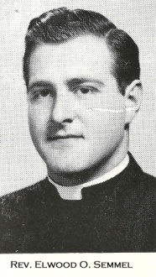
Elwood O. Semmel (Served 04/08/1956 – 01/15/1960) – Elwood O. Semmel was born on June 26th, 1930. He was a graduate of Muhlenberg College and Mt. Airy Seminary. Prior to serving in Auburn, the Reverend Semmel did parish work in Upper Darby, PA. He was elected to the Auburn Parish on April 8th, 1956. Reverend Semmel resigned from Auburn on December 6th, 1959 in order to serve the Home Mission Church in Hatboro, PA. His resignation took effect on January 15th, 1960. As a parting gift, he received “a handsome piece of luggage” from the church council. Reverend Semmel died on November 19th, 2003 and is buried in the Neffs Union Cemetery; Neffs; PA; Plot: X 640.

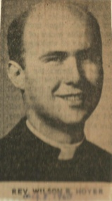
Wilson R. Hoyer (Served 08/15/1960 – 1963) – Wilson R. Hoyer was married; his wife’s name is currently undetermined. She was an invalid. He had a son named Mark Wilson Hoyer whom the Reverend Hoyer baptized. Reverend Hoyer was favorably viewed by some members of the congregation because, among other activities, he would play softball with the children of the congregation. Reverend Hoyer served the Auburn parish from August 15th, 1960 through 1963.

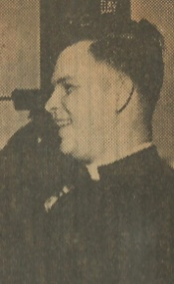
Robert C. Kistler (Served 1963 – 1967 or 1968) – Robert C. Kistler was born in Hazleton, PA circa 1935. His parents were Charles N. (1901 – 1989) and Dorothy (1909 – 1980) (Wetterau) Kistler. He graduated from Lehigh University in 1957 and the Lutheran Theological Seminary of Philadelphia, PA in 1960. He also was ordained in the Christ Lutheran Church of Hazleton in 1960. He married Margaret DeFrain. He had two children named Mary and John. The Reverend Kistler served the Auburn parish from 1963 through either 1967 or 1968 (conflicting reports exist). He resigned from Auburn to serve in Bethlehem, PA. Reverend Kistler died as a result of a long illness on August 19th, 1976 at 41 years of age.
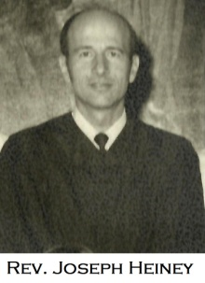
Joseph Heiney (Served 04/1963 – 07/1973) – Other than his period of service with the Auburn parish from April of 1963 through July of 1973, there is no other information available about the Reverend Heiney at this time.

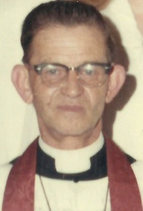
Luther J. Linn (Served 05/26/1968 – 08/1980) – Luther J. Linn was married and had a son named David. The Reverend Linn received the call from Auburn parish on May 26th, 1968. He was officially welcomed into the church in August of 1968. A member of the congregation remembered Pastor Linn as being a very strict and uncompromising individual, stating that Pastor Linn seemed to believe that “it was his way or the highway”. One resident recalled her dislike of Pastor Linn, stating that during a period in which she was absent from the church while caring for her terminally ill father, Pastor Linn sent her a nasty letter chastising her for her extended absence, stating her father’s illness was no excuse for her to not attend church. While at Auburn in August of 1980, he both resigned and retired from ministry. Pastor Linn died in August of 1987.

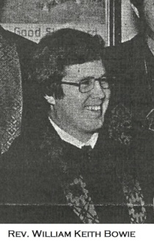
William Keith Bowie (Served 11/08/1973 – 1978 or 1979) – The Reverend William Keith Bowie’s wife’s name is Pamela. Reverend Bowie accepted his position at St. John’s Church in Auburn, PA on September 2nd, 1973. He was ordained on September 23rd, 1973 at the Grace United Church of Christ, Richland, Virginia. He was officially installed in Auburn, PA on November 8th, 1973. He left the Auburn parish in either 1978 or 1979 (conflicting reports exist).

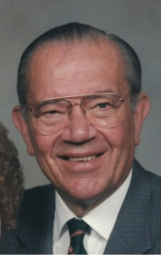
Donald Thomas Floyd (Served 1979 – 01/04/1981) – Donald Thomas Floyd was born May 13th, 1920. His wife was Florence May Floyd (a commissioned missionary). His children included Donald Thomas Floyd, Jr.; Janet Carol (Floyd) Schaefer; and Thomas James Floyd. Donald Floyd graduated from Reading High School, Reading, PA in 1938. He then graduated from the Eastern Baptist Theological Seminary in 1945 with a Bachelor of Divinity degree in Preaching and Parish Administration. He continued his education, graduating from the Lutheran Theological Seminary in 1945 with a Master of Sacred Theology degree in Old Testament and Christian Education. He also studied Theology (1948-1949) at Temple University School of Religion in Temple, PA, and was a full-time student for six months in 1963 at the Missionary Orientation Center. He was a full-time student for three months in 1963 at Drew University and he studied Linguistics and Cultural Anthropology (1963-1964) at the University of Ghana. He later studied Marriage Counseling and Family Education (1971-1972) at the Pastoral Institute of the Lehigh Valley, PA. The Reverend Floyd held several church positions prior to coming to Auburn to include a position as a Student Charge at the “Grace Evangelical Congregational Church, Harrisburg, PA from 1940-1945. He served at the Trinity Evangelical Congregational Church of Pottstown, PA from 1945-1954. He proceeded from there to the United Church of Christ at Glenside, PA from 1954-1963. He accepted a position as Field Secretary of the United Church of Christ Mission in Ghana from 1963-1965. He served the Pleasantville Church of Chalfont, PA from 1965-1973 and the United Church of Christ at Valley Forge, PA from 1973-1979. He resided in Royersford, PA prior to moving into the Parsonage at 242 Market Street, Auburn, PA. He began service with Auburn in 1979 and submitted his resignation letter on January 4th, 1981 in order to serve the Vincent Parish in Chester County, PA. During the course of his career, Reverend Floyd held numerous positions of importance with various services, committees, boards and other organizations. By all appearances, Reverend Floyd was a highly driven individual.
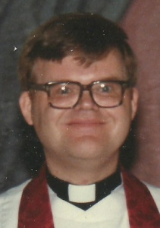
Philip K. Smith (Served 06/21/1981 – 08/31/1990) – The Reverend Philip K. Smith is a lifetime railroad and train enthusiast. He was installed at the Auburn parish on June 21st, 1981. He married his spouse Beverly (Faust) Smith in the St. John’s Church of Auburn in 1984. He left the Auburn parish on August 31st, 1990.

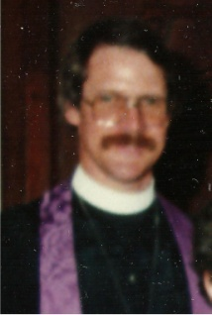
Gilbert L. Bartholomew (Served 09/20/1981 – 1985) – Gilbert L. Bartholomew was born in Pottstown, PA in 1943. His father was the Reverend Gilbert J. Bartholomew who also served the St. John’s Church of Auburn, PA (1996 – 1998). Gilbert (the son) graduated from the University of Pittsburg, PA in 1965. He also married Jane Titcomb in 1965. He received his Bachelor’s Degree from the Lancaster Theological Seminary in 1968 and his PH. D. in New Testament from Union Theological Seminary of New York in 1974. The Reverend Gilbert L. Bartholomew was ordained to the Christian Ministry of the United Church of Christ at St. Paul’s Church, Westminster, Maryland. He served as a Stated Supply Pastor to the Marysville-Enola (PA) Charge of the United Church of Christ and was an Adjunct Assistant Professor of New Testament at the Lancaster Theological Seminary. Reverend Bartholomew is listed as an Assistant Pastor in Auburn in a program dated May 31st, 1981 and he was installed at the Auburn parish on September 20th, 1981 and served until 1985.

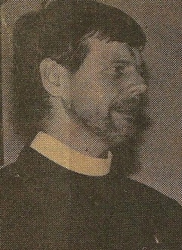
Charles Wonnenberg (Served 1985 – 1987) – The Reverend Charles Wonnenberg served the St. John’s Church of Auburn from 1985 to 1987. No other information is available at this time.

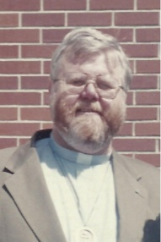
Gerald Alan “Jer” Baxter (Served 1991 – 1992) (Assistant Student Pastor) – Gerald Alan Baxter was born on December 21st, 1946 in Dayton, Ohio. His parents were Chester and Beth (Kern) Baxter. He served in the United States Air Force during the Vietnam era. He married Joanne Irene (Kimes) Baxter on January 24th, 1970 in Pottstown, Pennsylvania. They had two sons named Gregory Alan Baxter and Jonathan Erin Baxter. Assistant Student Pastor Gerald Alan Baxter served in the Auburn parish from 1991 to 1992. He was ordained at the Pennsylvania Theological Seminary of Lancaster, PA in 1992. Rev. Gerald Baxter died after a brief illness at 65 years of age on October 1st, 2012 in Harrison, Michigan.

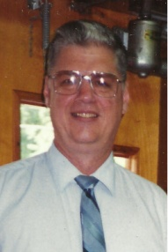
Larry Pierson (Served 1992 – 1993) (Assistant Student Pastor) – Assistant Student Pastor Larry Pierson served in the Auburn parish from 1992 – 1993. His wife’s name was Linda. No further information is available at this time.

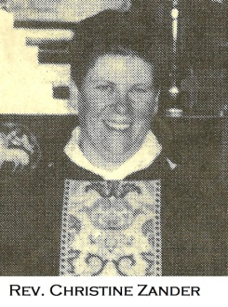
Christine Zander (Served 06/13/1993 – 1995) – Christine Zander was raised in Adamstown, PA. She attended Penn State University, the Gettysburg Lutheran Theological Seminary and the St. Vladimar’s Orthodox Theological Seminary (where she graduated in 1987 with a Master’s Degree in Divinity). At time of installation at St. John’s Church of Auburn on June 13th, 1993, the Reverend Zander was working on her third Masters Degree. She left the Auburn parish in 1995.

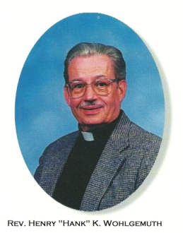
Henry “Hank” K. Wohlgemuth (Served 1995 – 1998) – The Reverend Henry “Hank” K. Wohlgemuth’s wife was Dorothy Wohlgemuth. At one time, he resided in Andreas, PA. Reverend Wohlgemuth was possibly ordained in 1957. He began service with the Auburn parish in 1995. He was affectionately referred to as “Pastor Hank” by some members of the Auburn congregation. Reverend Wohlgemuth was instrumental in the installation of more visible signage in town for St. John’s Church and Cemetery. In 1996, Reverend Wohlgemuth and his wife Dorothy donated the “Fair Linen for Holy Communion” from their trip to Israel. Reverend Wohlgemuth presented a combined Christmas Eve Service on December 24th, 1997 with the Reverend Harold Hollinger – this service marked the beginning of the combined Lutheran and UCC services at St. John’s Church of Auburn. His service at Auburn ended in 1998.

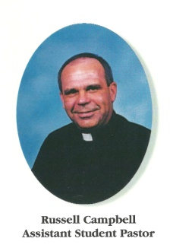
Russell Campbell (Served 1995 – 1996) (Assistant Student Pastor) – Russell Campbell was a resident of Ephrata, PA. He served as an Assistant Student Pastor at the Auburn parish from 1995 through 1996. No further information is available at this time.

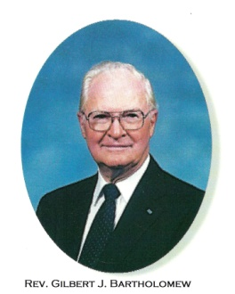
Gilbert J. Bartholomew (Served 1996 – 1998) – Gilbert J. Bartholomew was born on February 28th, 1914 in North Catasauqua, PA. His wife was Emma L. (Leinbach) Bartholomew (b. 1913 – d. 2009). His son was the Reverend Gilbert L. Bartholomew who had served St. John’s Church of Auburn from 1981 until 1985. Note: The Reverend Gilbert J. Bartholomew is listed in a program dated May 31st, 1981 that he himself was the Interim Pastor for Auburn while his son (Gilbert L.) was the Assistant Pastor. Rev. Gilbert J. Bartholomew (the father) died on October 29th, 2003 in Wernersville, PA at 89 years of age. He was buried in the Fairview Cemetery; Shillington, PA.
An obituary in the October 31st, 2003 edition of the Morning Call newspaper of Schuylkill County, PA reads “The Rev. Gilbert J. Bartholomew, 89, of 9 Reading Drive No. 1-011, Wernersville, Berks County, formerly of Red Dale Road, East Brunswick Township, Schuylkill County, died Oct. 29 in Phoebe Berks Health Care Center Inc., Wernersville. He was married to Emma L. (Leinbach) Bartholomew for 65 years in June.
A minister for United Church of Christ Ministries, he was pastor of St. Paul's Church, Westminster, Md., from 1963 until retiring in 1979. Previously, he was pastor of Lowell United Church of Christ, Canton, Ohio, 1957-63; Woodcrest Evangelical & Reformed, Philadelphia, 1952-57; St. John's UCC, Orwigsburg, 1946-52, and St. John's/St. Paul's, Pottstown and Stowe, Montgomery County, 1938-46.
After retiring, he was a supply pastor and interim pastor until 1996 for Christ UCC, McKeansburg, Schuylkill County; Friedens Church, New Ringgold; United Church of Christ, Auburn; Trinity Church, Tamaqua; Salem (Hetzel's) Church, Pine Grove, Pa.; St. John's Church, Port Clinton, Schuylkill County; Freidens Church, Shartlesville, Berks County, and St. Michael's Church, Hamburg.
He received a bachelor of arts degree in 1935 from Ursinus College; a bachelor of divinity in 1938 and a doctor of ministry in 1985, both from Lancaster Theological Seminary, and a master of sacred theology in 1947 from Temple University School of Theology.
Born in North Catasauqua, he was a son of the late Edwin J. and Meda M. (Wenner) Bartholomew. He was a member of St. John's United Church of Christ, Orwigsburg.
Survivors: Wife; sons, Gilbert L. of Cincinnati, Ohio, Edwin W. of Kingham, Mass.; daughter, Constance A. Blood of Moorestown, N.J.; four grandchildren.”

Harold Hollinger (Served 1997 – 1998) (Interim Pastor) – The Reverend Harold Hollinger began service to the Auburn parish in 1997. Reverend Hollinger presented the combined Christmas Eve Service on December 24th, 1997 with the Reverend Henry “Hank” K. Wohlgemuth – this service marked the beginning of the combined Lutheran and UCC services at St. John’s Church of Auburn. Reverend Hollinger left the Auburn parish in 1998.

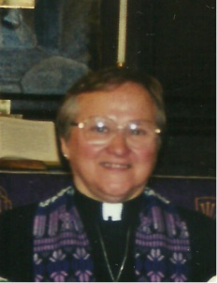
Melody Herr (-Bruen) (Served 10/01/1998 – 09/30/2002) – The Reverend Melody Herr was married to a Methodist minister. She was elected and began serving the Auburn parish on October 1st, 1998. She was the first pastor elected to serve both congregations in a joint pastorship. Reverend Herr was installed into the Auburn parish on November 22nd, 1998. Reverend Herr actively participated in the Appalachia Work Project in West Virginia during the summer of 1999. She also actively participated in a “Habitat for Humanity Project” conducted in Pottsville in 2000. Reverend Herr resigned from the Auburn parish on September 30th, 2002. She currently resides in Topton, PA.

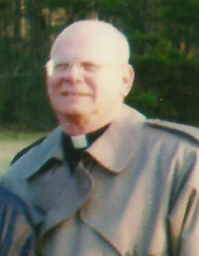
George Miller (Served 2003 – 04/16/2006) (Supply Pastor) – The Reverend George Miller was married. His wife’s name was Alberta. Reverend Miller served as a Supply Pastor to the Auburn parish from 2003 until April 16th, 2006. He and his wife reside in Wernersville, PA. No further information is available at this time.

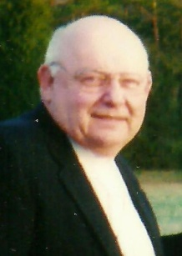
Arthur L. Hahn (Served 2003 – 04/16/2006) (Interim Pastor) – The Reverend Arthur Hahn was married. His wife’s name was Nancy. He currently resides in Topton, PA. The Reverend Hahn served the Auburn Parish as an Interim Pastor from 2003 until April 16th, 2006. No further information is available at this time.

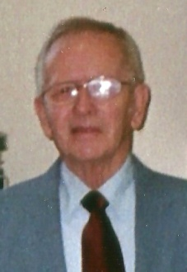
David Crowle (Served 04/16/2006 – 2006) (Interim Pastor) –
David R. Crowle was born on August 4th, 1931. His parents were Benjamin R. Crowle and Ann Mae (Hall) Crowle. Information pertaining to his present family has been retracted from this text as a result of a personal request. He graduated from Prospect Park High School in Prospect Park, PA. He then graduated from Elon College in Elon, NC with a Bachelors Degree in Philosophy and Social Services in 1954. He graduated from the Graduate School of Theology in Oberlin, OH in 1957 and was ordained in the Lansing Association of Congregational Christian Churches in Lansing, Michigan in 1959. He lived in four different states during his lifetime to include Michigan, North Carolina, Ohio and Pennsylvania.
The Reverend David Crowle served as an Interim Pastor to the Auburn parish beginning on April 16th, 2006. He left later than year but returned to St. John’s Church of Auburn from 2008 until 2011. No further information is available at this time.

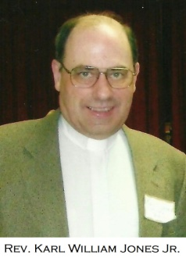
Karl William Jones Jr. (Served 09/12/2006 – 2008) – Karl William Jones Jr. was born on March 31st, 1946. He married Cathy Sue (Gross) Jones (b. June 18th, 1949) in 1967. His children’s names were Melissa and Matthew. Karl W. Jones, Jr. was a graduate of William Penn Senior High School, York PA in 1964. He graduated from Catawba College, Salisbury, North Carolina with a Bachelors Degree in 1971 and from the Lancaster Theological Seminary of Lancaster, PA with a Masters Degree in Divinity in 1974. The Reverend Jones served as the pastor of Orangeville Charge, UCC, Orangeville, PA from 1974 until 1980. He then served as pastor of the Jerusalem UCC; Palmerton (R.D. #1), PA from 1980 until 1985. He proceeded to become the Senior Pastor to St. Mark’s U.C.C. of Cressona, PA from 1985 until 2006. Reverend Jones was elected to the Auburn parish on June 11th, 2006 and transferred to Auburn on September 12th, 2006. He was installed at Auburn in November of 2006. Reverend Jones served as a member of the Pennsylvania Southeast Conference Ministry and Missions Team; Advisory Board Member to St. John’s UCC, Orwigsburg in Health Ministry; Member of the UCC Ministers in Higher Education; President of the Schuylkill Association Ministerium; Member of the Schuylkill Association Executive Committee; Member of the Board of the Schuylkill Haven and Vicinity Council of Churches; Member of the Pottsville Ministerium and Member of the National Campus Ministry Association. His religious activities included Board Chairman of the Schuylkill Alliance for Health Care Access; Treasurer and Grant Writer for the Unity Coalition of Schuylkill County; Board Member and Gate Chairman for the Schuylkill County Fair; District Chaplain, District 14-U, of the Lions Club International and Member of the Pennsylvania Welfare Coalition. His skills included “hands-on healing and Reiki”. He resides in Orwigsburg, PA. Reverend Jones left the Auburn parish in 2008.
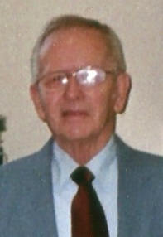
David Crowle (Served 2008 – 2011) (Interim Pastor) – The Reverend David Crowle had previously served the Auburn parish briefly in 2006. He returned to the Auburn parish again in 2008 and was instrumental in collecting significant financial contributions for the World Hunger Programs (Lutheran World Hunger and UCC “One Great Hour of Sharing”) as well as collecting contributions for repairs to the church organ costing almost $2,000. His fund-raising drive resulted in collecting not only the total repair costs but a surplus of over $800 which was placed into a special repair fund for church properties. He left the Auburn parish in 2011.

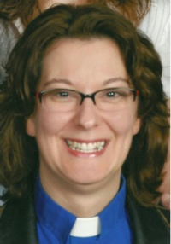
Darcy Marie (Boeve) Reis (Served 01/01/2012 - Present) –Darcy Marie Boeve was born on December 9, 1966 in Flint, Michigan. Her parents were John Ferrell Boeve and Trudy Ann (Dickerson) Boeve. In 1985, she graduated Swartz Creek High School located in Swartz Creek, Michigan. She later moved to the state of Washington where she resided for approximately 2½ years. She married her husband James Raymond Reis on Valentine’s Day of 1993 in the town of Silverdale, Washington. Their daughter Tara Anne Reis was born on December 18, 1993. Tara is blessed with a beautiful singing voice, often sharing this gift by having participated in the church choir or by singing solo arrangements for the congregation. The family eventually moved to Pennsylvania and they presently reside in Pottsville, PA.
Darcy Reis attended Cedar Crest College in Allentown, PA. In 2002, she graduated summa cum laude with a Bachelors of Arts in Communication Studies with Minors in Religion and Psychology. She then attended the Lutheran Theological Seminary of Gettysburg, PA, graduating in 2009 with a Masters of Divinity Degree. She also received a Seminary Award for Historical Studies. Her studies provided her with a fluency in the language of Kione Greek. The Reverend Darcy Reis was ordained at the Trinity Lutheran Church of Pottsville, PA on June 20, 2009 by Bishop Samuel K. Zeiser of the North East Pennsylvania Synod.
Reverend Reis served as an Associate Pastor at the Trinity Lutheran Church from 2009 until December 31, 2011. She received the call to St. John’s Church of Auburn, PA on November 27, 2011 and began her duties as Pastor there on January 1, 2012. In addition to these qualifications, Reverend Reis also serves on the Shared Ministry (U.C.C. & E.L.C.A.); she serves on the Pennsylvania Southeast Conference (PSEC) Ecumenical Relations and Missions Team; she serves as the Secretary of the Schuylkill Association of the PSEC; and she serves as a volunteer Pastor to lead worship and preside over Holy Communion on the first Sunday of every month at the Pine Brook Retirement Community of Orwigsburg, PA.
Reverend Reis accepted her position at St. John’s Church for many reasons to include the fact that she looked forward to the opportunity to serve a shared ministry with a combined service. During a study conducted in 2014, ten local churches which have shared ministries and Lutheran Congregations (like that of Auburn) were compared. The lowest of the ten showed only 7.87% of Baptized Members attended worship regularly. The second highest of the ten local churches showed 25.25% of Baptized Members attending worship regularly. However, St. John’s Church of Auburn under the guidance of Pastor Reis showed an impressive 54.26% of Baptized Members attending worship regularly. Within her first year at St. John’s of Auburn, the lower level of the Church structure was extensively remodeled to include many improvements over the existing structure. Pastor Reis took an active role in the remodel process by coordinating with the contractor for the duration of the project. From a physical aspect, she hopes that the church will meet the needs of many of the elderly or medically-challenged congregants by constructing a handicap-accessible restroom on the Main Level of the church.
In addition to her aforementioned accomplishments while at St. John’s, Reverend Reis is highly regarded by many members of the congregation. She has frequently received praise for her ability to effectively interact with the children of the congregation. Some of the Pastor’s most cherished moments at St. John’s Church occur when the children become visibly excited to participate in the services.
Reverend Reis also is admired for her ability to blend the historic gospels with modern parables and terminology. She accomplishes this task without losing, or in any manner disrespecting, the original message of the Gospel, thus making sermons and teachings more relevant and easily understood by all present. Her knack for assimilating Biblical messages into present, relevant scenarios keeps her sermons both interesting and unique. Reverend Reis was highly instrumental in the organization of archival documents of this church.
Reverend Reis resigned from St. John’s Church of Auburn in April of 2015.

