Fahl Family Cemetery
North of Route 895*

NOTE: This cemetery is situated on private property. © 2015 --- A.A.H.S.

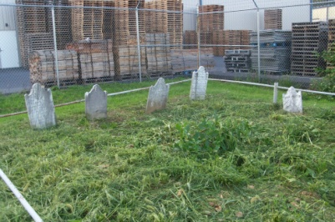 | This cemetery is listed on the internet
 | as having five separate interments due
 | to having five apparent headstones; but
 | one of these stones is suspected of
 | being a “footstone” for another grave.
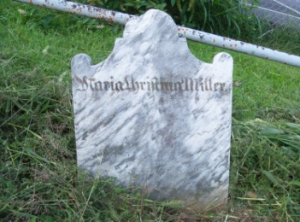 | This marker was believed to indicate a
 | separate interment but is now suspected
 | of being a large “footstone” for the
 | same Maria Christina (Fahl) Miller who
 | was interred here in June of 1811.
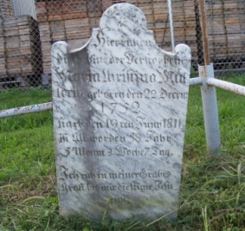 | Maria Christina (Fahl) Miller --- Born
 | December 22, 1752. (NOTE: The D.O.B.
 | was actually 1776). Died June 19, 1811.
 | This is the earliest known “still visible”
 | interment in the immediate Auburn area.
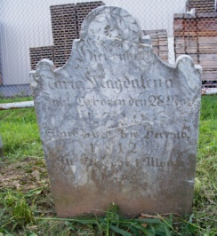 | Maria Magdalena Fahl --- Born November
 | 28, 1739. Died December 30, 1812. She
 | was the wife of Jost Fahl and Mother
 | of Diedrich Fahl and Maria Christina
 | (Fahl) Miller.
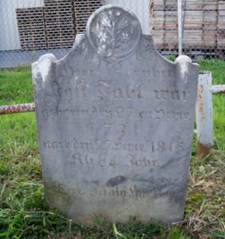 | Jost Fahl --- Born September 27, 1731.
 | Died September 27, 1815. (NOTE: Jost
 | died on his birthday). Husband of Maria
 | Magdalena Fahl & Father of Diedrich
 | Fahl & Maria Christina (Fahl) Miller.
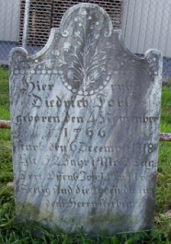 | Diedrich Fahl --- Born November 4, 1766.
 | Died December 6, 1818. Son of Maria
 | Magdalena Fahl and Jost Fahl. Brother
 | of Maria Christina (Fahl) Miller whose
 | D.O.B. is believed to actually be 1776.

