St. John’s Church of Auburn, PA
Pastors of the first 100 Years

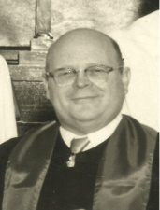 | 1948  1955 | Raymond C. Zechman – Reverend Raymond C. Zechman
 |  | served as Pastor for St. John’s Church of Auburn, PA for
 | R | approximately seven years before resigning in order to
 |  | perform missionary work among Native Americans.
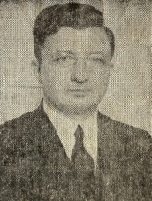 | 1954  1955 | Fred Chartron – Reverend Fred Chartron served as Pastor of
 |  | St. John’s Church of Auburn for approximately one year
 | L | before resigning to accept a position as Pastor for the
 |  | St. Peter’s German Lutheran Church of Allentown, PA.
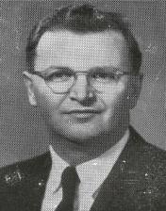 | 1956  1962 | Warren O. Ziegler – Reverend Warren O. Ziegler wrote a
 |  | booklet titled “St. John’s United Church of Christ – Auburn,
 | R | Pennsylvania - 1959 – A self-study by the Congregation”
 |  | providing insights on the congregation & St. John’s Church.
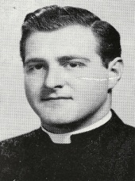 | 1956  1960 | Elwood O. Semmel – Reverend Elwood O. Semmel had
 |  | resigned from St. John’s Church in January of 1960. He
 | L | received “a handsome piece of luggage” from the church
 |  | council as a parting gift for his dedicated service.
