St. John’s Church of Auburn, PA
Pastors of the first 100 Years

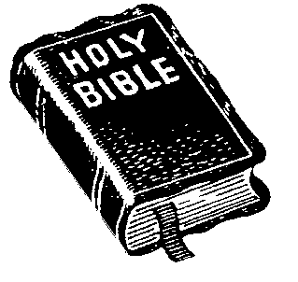 | 1845  1852 | Nathan Jaeger – Reverend Jaeger was the first pastor to
 |  | serve Scotchman’s Locks (now known as Auburn, PA). He
 | L | resigned under a cloud of controversy over his “secular
 |  | engagements” and “worldly pursuits”.
 | 1845  1857 | Philip Meyer – The Reverend Philip Meyer served the
 |  | area later referred to as the “Auburn Parish” from 1845
 | R | to 1857. No further information is available at this time
 |  | regarding the Reverend Meyer.
 | 1852  1852 | George W. Scheide – Although Reverend Scheide had
 |  | only begun preaching in Auburn in January of 1852, on
 | L | December 25th, 1852 he was instructed to resign by
 |  | Lutheran board members because of his “fanatical habits”.
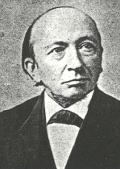 | 1853  1860 | Julius Ehrhart – Reverend Ehrhart began his Auburn term
 |  | at the “Meeting House” and ended it at “St. John’s Church”.
 | L | He was once described as possessing “great oratorical
 |  | ability and personal magnetism”. He died in 1899.
 | 1858  1865 | Henry Wagner – The Reverend Henry Wagner started his
 |  | service at St. John’s Church of Auburn in 1858. He left
 | R | St. John’s Church of Auburn in 1865. He died on Sunday,
 |  | May 23rd, 1869 and was interred in Lebanon, Pennsylvania.
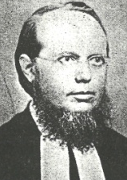 | 1861  1864 | Karl Friedrich William Hoppe – The Reverend Karl Friedrich
 |  | William Hoppe was born in 1824 in Hanover, Germany. He
 | L | immigrated to America when he was twenty-eight years
 |  | old. He served the Auburn parish for thirty months.
 | 1864  1864 | John Henry Eberman – Reverend Eberman began service as
 |  | Moravian but converted to Lutheran. An excerpt reads:
 | L | “In consequence of domestic troubles he exchanged the
 |  | service in the Moravian Church for that in the Lutheran…”
 | 1864  1869 | F. Leonberger – The Reverend Leonberger was elected to
 |  | the Auburn Parish on Sunday, December 25th, 1864.
 | L | Records indicate that Reverend Leonberger did much of his
 |  | pastoral work while mounted on horseback.

