 |  |  | 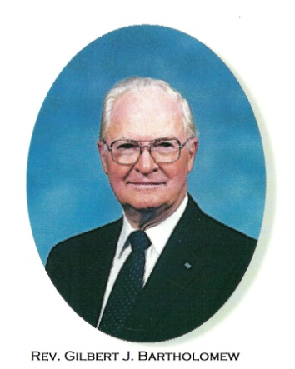 |  |  | 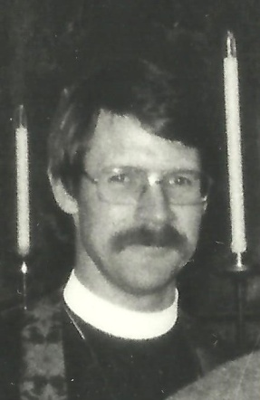
Appel,  Rev. Richard S. |  |  | Bartholomew,  Rev. Gilbert J. |  |  | Bartholomew,  Rev. Gilbert L.
1865 - 1873 | R |  | 1996 - 1998 | R |  | 1981 - 1985 | R
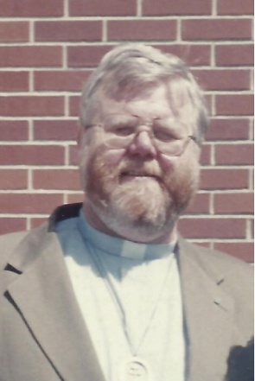 |  |  | 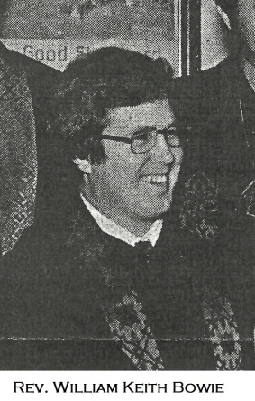 |  |  | 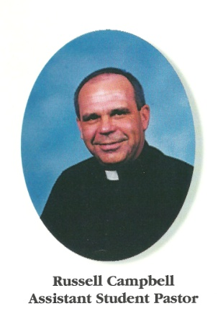
Baxter,  Rev. Gerald |  |  | Bowie,  Rev. William K. |  |  | Campbell,  Rev. Russell
1991 - 1992 | R |  | 1973 - 1979 | R |  | 1995 - 1996 | R
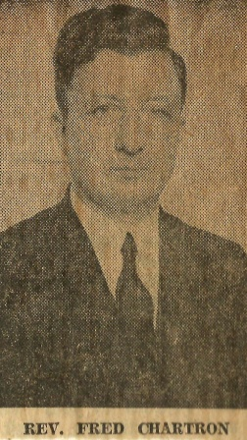 |  |  | 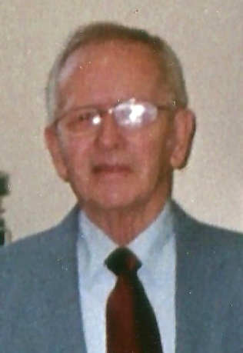 |  |  | 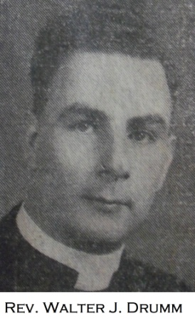
Chartron,  Rev. Fred |  |  | Crowle,  Rev. David |  |  | Drumm,  Rev. Walter J.
1954 - 1955 | L |  | 2006 & 2008 - 2011 | J |  | 1942 - 1946 | L

