“Mengel’s Eck” Family Cemetery
Three miles east of Auburn, PA*

*NOTE: This cemetery is located on private property.

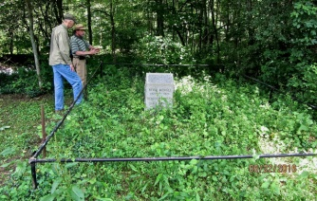 | The “Mengel’s Eck” Family cemetery is located
 | approximately three miles east of Auburn, PA on
 | the mid-1800s farm of Peter Mengel. “Eck” is a
 | German term for “corner”. This particular area
 | had numerous Mengel families residing within it.
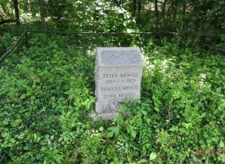 | David Mengel* --- Born November 19, 1862. Died in
 | infancy; exact date uncertain. Son of Peter* and
 | Mary Faust Mengel. Brother of Acquilla Mengel,
 | Catharine Mengel Reber, Clara Mengel, Phebe
 | Mengel Greiner, Rebecca Mengel* & Zeno Mengel*.
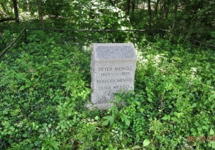 | Peter Mengel* - Born 1824; Died October 2, 1878.
 | Son of Conrad Mengel & Susanna Rishel Mengel.
 | Husband of Mary Faust Mengel. Father of Phebe
 | Mengel Greiner; Catharine Mengel Reber; plus
 | Acquilla, Clara, David*, Rebecca* & Zeno Mengel*.
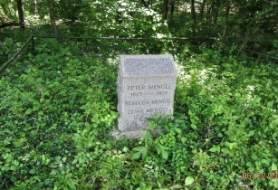 | Rebecca Mengel* - Born January 22, 1877; Died in
 | Infancy, date unknown. Daughter of Peter* and
 | Mary Faust Mengel. Sister of Acquilla Mengel,
 | Catharine Mengel Reber, Clara Mengel, David
 | Mengel*, Phebe Mengel Greiner and Zeno Mengel*.
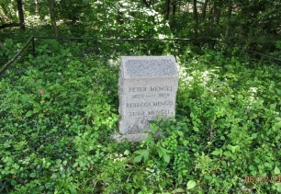 | Zeno Mengel* - Born July 9, 1878. Died in infancy,
 | Date unknown. Son of Peter* and Mary Faust
 | Mengel. Brother of Acquilla E. Mengel, Catharine
 | Mengel Reber, Clara Mengel, David Mengel*,
 | Phebe Mengel Greiner and Rebecca Mengel*.
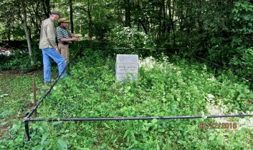 | “Mengel’s Eck” Cemetery is listed by some sources
 | as containing four separate graves --- one adult’s
 | and three children’s. Presently, it appears as if
 | The cemetery contains just a single more recent
 | Joint monument for one adult and two children.

*Individuals notated with an asterisk are believed to be interred here.

© 2016 --- Auburn Area Historical Society (AAHS)

