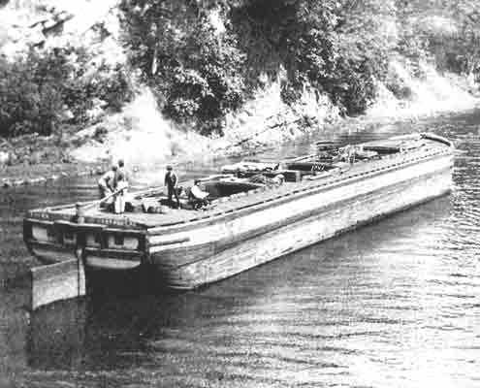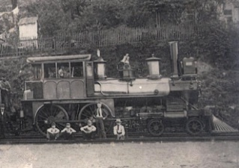
P.O. Box 114; 451 Pearson Street; Auburn, PA 17922
www.auburnareahistoricalsociety.weebly.com

Lifetime Membership Application
(Please Print Legibly)

Name (First, MI, Last): _______________________________
Mailing Address: _______________________________
_______________________________
_______________________________
Telephone Number(s): _______________________________
_______________________________
_______________________________
E-Mail Address (if any): _______________________________
List any special interests: _______________________________
_______________________________
_______________________________

I AM INTERESTED IN THE FOLLOWING FORM(S) OF PARTICIPATION:

X | ACTIVITY | X | ACTIVITY
 | Assist with an annual calendar |  | Monitor Open Houses
 | Assist with an annual yearbook |  | Photograph historic objects and/or sites
 | Assist w. carpentry/electrical/plumbing |  | Plan events and/or fund raisers
 | Assist with creating a cookbook |  | Plan “field trips” to historical sites
 | Assist with events and/or fund raisers |  | Prepare and/or preserve memorabilia
 | Assist with a monthly newsletter |  | Proofread written histories or documents
 | Attend AAHS meetings |  | Pursue historical marker(s) for Auburn
 | Be a guest speaker at AAHS meetings |  | Research deeds at county courthouse
 | Be a guest speaker at other functions |  | Research historical facts
 | Create and/or maintain displays |  | Serve as an AAHS Officer
 | Create/research genealogies |  | Solicit donations of materials
 | Distribute/post flyers |  | Solicit donations of memorabilia
 | Interview Auburn residents about history |  | Solicit donations of money
 | Locate and/or obtain memorabilia |  | Solicit Memberships
 | Locate guest speakers for presentation |  | Other:

(Lifetime Membership fee is a one-time payment of $50 by Cash, Personal Check, Cashiers Check or Money Order made payable to the “Auburn Area Historical Society”. Please do NOT send any cash payment via U.S. Mail as we cannot guarantee its arrival and receipt.)

