Fahl Family Cemetery
West of Fort Lebanon Road*

*NOTE: This cemetery is located on private property. © 2015 --- A.A.H.S.

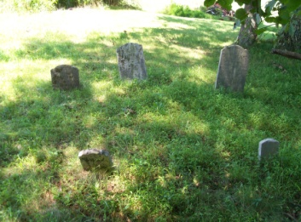 | This cemetery is listed by some sources as
 | having 5 graves --- 3 adults & 2 children;
 | However, it appears as if the cemetery
 | actually contains three adult interments
 | and two “footstones” for those graves.
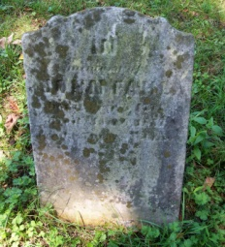 | John Fahl --- Born September 7, 1771.
 | Died January 7, 1857. Son of Johann
 | Dieter Fahl. Husband of Mary Elizabeth
 | (Wildermuth) Fahl. Father of Henry Fahl
 | (who is interred here) and Elizabeth Fahl.
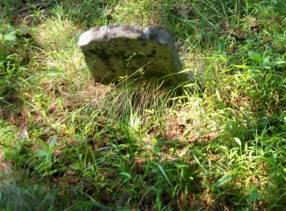 | This stone was assumed to have been an
 | Individual interment, possibly for a child.
 | Upon further examination, this stone is
 | believed to probably be a mere footstone
 | for the grave of John Fahl.
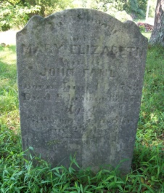 | Mary Elizabeth (Wildermuth) Fahl --- Born
 | June 14, 1783. Died February 13, 1874.
 | Wife of John Fahl. Mother of Henry Fahl
 | (who is interred in this cemetery) and of
 | Elizabeth Fahl (who is not interred here).
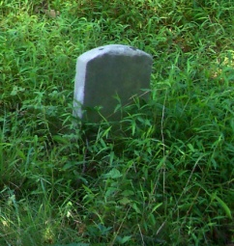 | This stone was assumed to have been an
 | Individual interment, possibly for a child.
 | Upon further examination, this stone is
 | probably a mere footstone for the grave
 | of Mary Elizabeth (Wildermuth) Fahl.
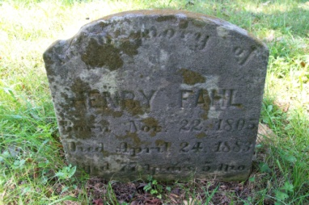 | Henry Fahl --- Born November 22, 1805.
 | Died April 24, 1883. Son of John Fahl &
 | Mary Elizabeth (Wildermuth) Fahl, both
 | of whom are interred in this cemetery.
 | Brother of Elizabeth Fahl.
*NOTE: Folklore stated this cemetery was the result of a deadly Indian attack on a local family, claiming the bodies were buried where they fell. If this were really true, it was the longest massacre in history since the dates span twenty-six years.

